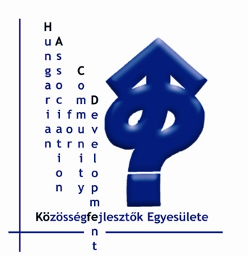 | Közösségfejlesztők Egyesülete  Association for Community Development  Association du Développement Communautaire  1011 Budapest, Corvin tér 8.  1251 Budapest, Pf. 42  E-mail: kofe@kkapcsolat.hu  Telefon: (36-1) 201 57 28, Fax: (36-1) 225-60-13, www.kka.hu

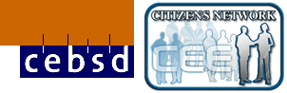

European Dialogue – International follow-up workshop, 6-7th of June 2008, Kunszentmiklós-Kunbábony

That was in the application:

With the participation of the applicant HACD (4 people) and its partners, the CEBSD and CEE CN coordinators, 6-7 June 2008, Budapest (the foreign participants will arrive on 5th and leave on 7th)
Tasks: to evaluate the project, to generate the plan of cooperation between the two networks and to jointly plan the follow-up.
On the completion of the project HACD will prepare the project closing report and will submit it to the Europe for Citizens Programme.

- project evaluation, additions to the HACD evaluation,
- evaluation of project ideas, selection of key ideas, collecting ideas on supporting their implementation
- possible ways of cooperation between the two networks – agreeing network strategies, considering opportunities of development

Programme for the meeting

6th of June, Friday

Until 15:00 – arrivals and lunch

15:00 – 17:00

- Short report on the ED Seminar and it’s activities, more details and participant’s evaluations
- Discussion on the ED seminar, general evaluation of the organizing bodies, CEBSD, CEECN, HACD

17:00 – 18:00

- What happened since the ED in the three organisations? Present situation of the two networks? General feelings on the organisation’s present and close future.

7th of June, Saturday

9:00 – 10:00
- Reports and feedbacks on the Cafe Dialogue results and the timeline prepared (that should be done as a shared task)

10:00 – 11:00
- General toughts on possible future cooperation of the three bodies, priorities, interests, strategy, resources, time

11:00 – 12:30
- Creation of a common paper, like a strategy, or pro-active plan on the agreed activities and shared tasks

12:30 – 13:00(?)
- What and how to report?

13:30 – Lunch and departures

Time Line of follow-up from European Dialogue Seminar
Theme | Sub-themes | May-Aug 2008 | Sept-Dec 2008 | 2009 | 2010
Dialogue with Civil Society | European Dialogue | 6-7th June  Meeting Budapest Hungary
Dialogue with Civil Society | Citizen Participation | „infrastructure” for communicating, exchanging and space for being  visible  Propose some joint activities and plan for funding, explore existing sources  International organisation for local authorities  National organisation with network in own country | Citizen Participation Week in last week of September  European Week of local democracy 15-21 October  Knowing what is going on and who is involved  Dialogue between CEGA and IRDSU on how to approach Rom (Gypsy) issues in Community Development work | International Seminar with ALDA-LDW  Citizen Participation Week in September  European Week of local democracy October  CEECN conference combined with Ruralnet Romania | Citizen Participation Week  European Week of local democracy  Network of networks from 2010 on continuation of citizen dialogue
Dialogue with Civil Society | People in Politics: European Partnership | PP Meeting 28th-30th May in Malmo,Sweden | PP Meeting September in Hungary | PP Meeting in May 2009 in Oslo
E- participation | Websites |  | Co-ordinating latest news from each website –recriprocity between the info on websites | Show the results of Intercultural Dialogue  Support funds for updating websites in English for each organisation
E- participation | PEP-NET project
E- participation |  |  | Develop Communication channels between networks  East-west Communication on developments of CP and Community Development  (context of contract culture)
Influencing Policy | Council of Europe
Influencing Policy | European Social Platform
Influencing Policy | World Social Forum |  | European Social Platform on 18-20 September in Malmo, Sweden | World Social Forum in January in Brazil

Cafe dialogue groupwork during the ED meeting, 9th of May, 2008, Kunbábony.

Group 1

Differences and similarities in European civil society

Random notes from the table:
- The civil society is not the collection of NGO’s, it is broader and consists spontaneous and non formal cooperations, actions
- There are big differences between CEE and WE in history, traditions and culture
- In spite of that we can rather say that the framework is different, the values are quite similar, and these are important
- The WE civil society is more formalized, structured
- The CEE civil society has a special „socialist” social capital, where the citizens got the „skill of poverty” (to be successful with the lowest amount of resources), but that is transforming now and more and more similar to the West’s consumer society.
- The West already fallen asleep, politics are very far from the people (too much structures between them?)
- In the CEE region the state support is much lower and it is concentrated to support the service providers (reformulating the dependence towards the state), that decreases the self organization and responsibility in society.
- In spite of that movement and actions seems to be more present in CEE

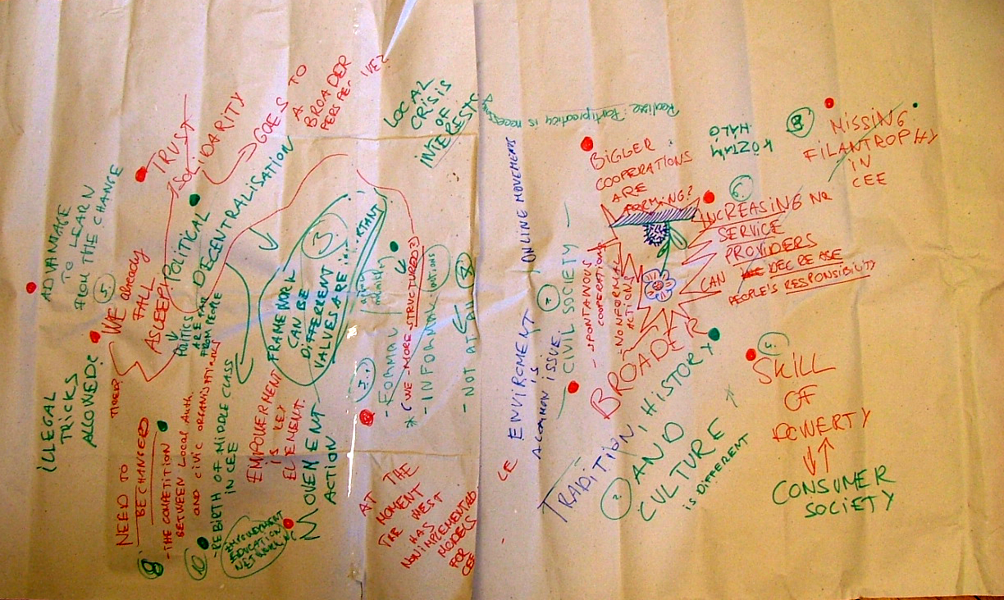

Need to be changed:
- The competition between civic organizations and local authorities (people and politicians) – that would go through education and trainings
- Help to create structures for the civic voices, decentralization of the politics, policies
- Help the rebirth of the middle class, which is more and more missing in CEE, through that philanthropy could be enforced
- Increase trust and solidarity
- Empowerment, education and networking could fill the gap between CEE and WE
Our priorities were:
- Increasing organizational level
- Training politicians and civics’ on each others role
- Increase trust and solidarity

We suggest:

Short term | 1. Extension of the Citizens Participation Week to WE  We should invite and motivate the CEBSD members and possibly other WE NGOs to participate in the event.  The first step could be to start in the People and Politics project, which has some events this year, Malmo in May, 2008 September in Hungary (during the CPW), and Norway at the end of the year
Short term | 2. Use the TLCD project to define long term goals in networking for supporting the training of the politicians and civics in each others role  3. To link and develop together the Best Practice Database (CEECN) and the Good Practice (CEBSD) project. „Visit and see”
Long term | 1. Create a „Network of Networks” with the intention of learn from each other. There are a lot of organizations who run nation-wide networks. The organizations who are Network-developers in their own countries have a wide-range knowledge and public influence too, that could be the basis of the cooperation. Those could be: CAL – Poland, KÖTÁMHÁLÓ - Hungary, CKO - Slovakia, CCI – BIH, Croatia, CEGA – Bulgaria

Group 2

Cafe Dialogue

Including the Excluded
How can the excluded include the excluded?
Community workers and community activists are often marginalised and excluded from systems and structures so this makes it difficult for them to make sure that people who are excluded are included in mainstream services and structures and can participate in planning and policy.

Working not only with a specific target group but with all people at a local level

Working only with a specific target group can lead to local resentment. It can be more successful to set up something which is more inclusive from the outset.
Officially labelling people limits them
Putting one label on people e.g. people who are wheelchair users, Roma etc. can lead to making generalisations and fitting people under a label and limits the possibilities of seeing that people have multiple identities and many different ways of being part of a community.
Ethnic groups or people with a disability includes people who are rich, poor, professional, workers, unemployed, men, women, elderly, children etc. There are many different routes into community life.
Training based on action and learning by doing

There was a strong emphasis on the importance of action and on „learning by doing” as one means to connect to excluded groups.

We need common forms of communication
For international work, knowing English can be an advantage as it is often the common language of communication. Creative ways of working and of communicating e.g. mime, theatre, active methodologies e.g. Cafe Dialogue can also help.
Group 3

Local elections and local representation
Ivana Bursikova, Agora CE, CR

Roles of NGO’s between elections:
Education of political parties
Monitoring of governmental activities

During eletion campagn:
Organising Local forums
Debaitng with youth
Monitoring campaign (expenditures)
Campaigning pro elections – you should govoting, othervise you cannot complain

Dangers:
Ngo’s when supported by government might loose their autonomy and credibility
When people from NGO’s go to politics, they might be inexperienced

Recommendations:
Make the election proces s longer (in order to be able to find response from andidates on peoples guestions)
Nordic approach – when the turnout goes under 6O %, the state shoudl adopt some measures

Group 4

CAFÉ DIALOGUE: INTERCULTURAL DIALOGUE

The „Table” dealt with the issue of „intercultural dialogue”. Once the statement was made that „intercultural” didn´t only qualify the encounter between ethnical grups, but could also concern different cultures within a same country or city (i.e the punkies and the eldery of an area, for instance), the differents contributions made through the process could be gathered in 3 clusters:

- the Context

It is very important to put the intercultural dialogue into context, i.e:

- To know the degree of fear or prejudices due to terrorism
- To measure the effect of globalisation on the relation between different cultures
- To check the distance which has been created between the different cultures because of the economical crisis

It is also important to apply a multiprospect approach to such a dialogue, i.e to consider that it is necessary to take into account all the economical, social and political aspects of the problem

Finally, one must be aware that sometimes such a dialogue could be part of a hidden agenda of politicians who just want to avoid larger problems. Then, it is important to regain the true issue in the agenda, by promoting the real dialogue.

- The obstacles

The main obstacle to true intercultural dialogue consists of the „wrong approaches” appliedb, i.e:

- prejudices, which biase the relation between people from different cultures.
- U.E (and national) policies which often promote positive discrimination and don´t help the relations between grups equally marginalized
- the demand of rights, when not accompanied by the commitment towards duties.
- The idea of assimilation when it is seen as the way to promote co-existence.
- The lack of long term visions

- The proposals to promote such a dialogue

Many proposals were put forward for consideration:

- To give voice through the dialogue
- To promote youth involvement in order to make the process sustainable
- To use the „stories of life” methodology in order to create bridges between the cultures in confrontation
- To use the „tandem” methodology, by putting together, in a same project, people belonging to the 2 sides of a conflict (policemen and immigrants for instance, etc...)
- To apply international cooperation to manage a conflict or pormote the intercultural dialogue in a country where a conflict has occured
- To encourage policies which protect diversity.

From these many suggestions, 3 were given higher priority:
- the stories of life
- the tandem
- the involvement of Youth

