Community Organizing

Chuck Hirt

Overview of the Community Organizing Methodology

“Let me give you a word on the philosophy of reform. The whole history of the progress of human liberty shows that all concessions yet made to her august claims have been born in earnest struggle. The conflict has been exciting, agitating, all absorbing, and for the time being putting all other tumults to silence. It must do this or it does nothing. If there is no struggle, there is no progress. Those who profess to favor freedom, and yet depreciate agitation, are men who want crops without plowing up the ground. They want rain without thunder and lightening. They want the ocean without the awful roar of its many waters. This struggle may be a moral one; or it may be a physical one; or it may be both moral and physical; but it must be a struggle. Power concedes nothing without a demand. It never did and it never will. Find out just what people will submit to, and you have found the exact amount of injustice and wrong, which will be imposed upon them; and these will continue until they are resisted with either words or blows, or with both. The limits of tyrants are prescribed by the endurance of those whom they oppress.”

Fredrick Douglas
Letter to an American Slavery Abolitionist – 1849
Quoted from Forward to Organizing for Social
Change.

This quote perfectly describes the heart of community organizing. People need to take power into their own hands and organize among themselves, in order to implement changes. Community organizing, therefore, is one of the key methods of citizen participation at the local level.

What is Community Organizing?

In simple terms, community organizing is a combination of three things:

- Building power through involving a constituency in identifying problems they share and the solutions to those problems that they desire;

- Identifying the people and structures that can make those solutions possible, enlisting those targets in the effort through negotiation, and using confrontation and pressure when needed;

- Building a community-based organization that is democratically controlled by a constituency and can develop the capacity to take on further problems, and that embodies the will and the power of that constituency.

Community organizing is a methodology of community work which originated in the United States. Organizers in the U. S. found it helpful to distinguish their work from three other forms of community based strategies; namely advocacy, service delivery, community development.

Three principles:

- Win real, immediate, concrete improvements in people's lives

- Give people a sense of their own power.

3. Alter the relations of power.

II. Context for Using Participatory Methodology

Community organizing starts from a different point than focusing on the relationship between citizens and local government, Community organizing is concerned about citizens involvement in the public arena (as opposed to the private or personal arena) which includes both government, business as well as the citizen and NGO sector. It is the interplay of all three that forms the public arena.
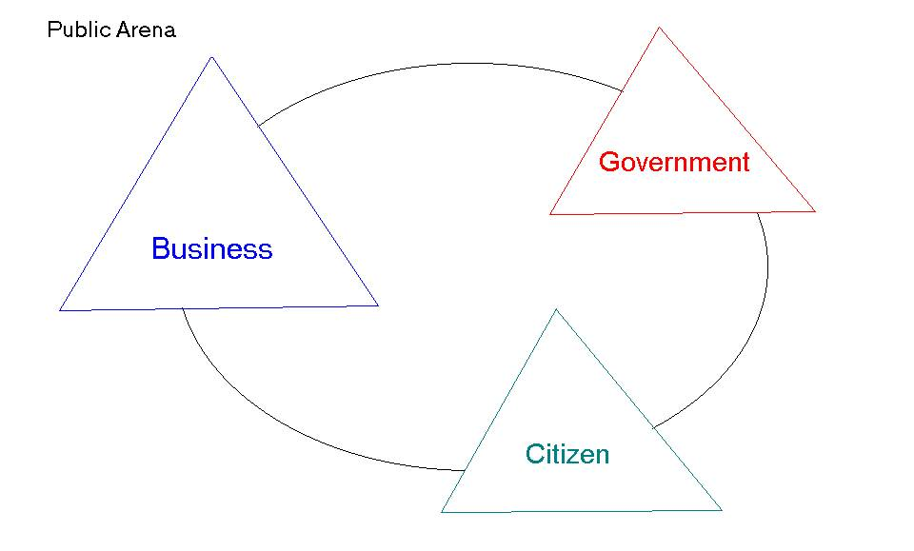

The focus of organizing work is not only on developing the citizens‘ capacity to engage with government as some other public patricipation strategies emphasize. Organizing starts with an emphasis on developing the citizens capacity to engage with either the governement, business and possibly even other NGO’s. Citizens need to be prepared to deal with anyone else operating in the public arena and with whom citizens need to negotiate in order to get their needs met.

Also, community organizing does not concern itself with the nature of the relationship between government and citizens. Governments are free to choose whatever relationship they wish with citizens. Obviously, things work better in an environment of participation and collaboration but sometimes governments choose other means. Either way, citizens need to be able to learn how to engage.

III. Process and Steps for Successful Implementation of the Community Organizing Methodology

Often community groups are ineffective, as they are quick to rush to a particular tactic, for instance writing a petition without taking the appropriate steps to help the group assess whether or not it will help their cause.

Community organizing requires careful planning just like government and business. There are eight steps involved in community organizing work. The eight steps are: (following this brief step guide will be more detailed information on several of the items like identifying the issue, or developing the strategy):

- Identify the issue. In this step, information about the problems that exist in communities is gathered. The community organizer carries out most of this initial work by conducting hundreds of personal interviews with citizens. Citizens then sort out these problems, choose one, and begin working on it. The problem is then narrowed down and particular solution(s) are identified.

Criteria for identifying an issue

A variety of criteria should be considered in choosing an issue. Not all of these criteria will apply in every situation, but the ability to maximize the largest number of them would be optimal. Consider following this checklist of possibilities before choosing an issue:

- Results in real improvements in people’s lives
- Gives people a sense of power
- Alters the relations of power
- Is worthwhile and winnable
- Is widely felt and deeply felt
- Is easy to understand
- Has a clear target
- Has a clear time frame that works for you
- Is non-divisive and builds leadership
- Sets your organization up for the next campaign
- Is consistent with the organization’s values and vision

- Get the background information on the issue. Doing our homework is still important. To be effective in the public arena, we must be competent in our work. This requires that we know all that we can about the issue, who has the power to bring about changes we want. Ideas about what will be needed to bring about these changes are especially essential.

- Define the goal. At this stage the group really focuses on its task. The agenda here is to not only clarify the actually goal in terms of solving the issue, but to also clarify the goals for the group itself. The question that has to be asked here is: What do you want the results of your work to be?

- Plan the strategy. Many new groups start the process of community organizing at this stage, and it is usually a mistake. It happens very often that when community groups get together for the first time, they talk briefly about a problem, and immediately start discussing possible tactics, for example writing a petition, or arranging a meeting with the local city council member(s). Unfortunately, this usually leads to failure, as groups are not prepared to discuss strategy until they have completed the previous three steps. With the goal in place, the group can then proceed towards identifying the possible supporters and opponents, the target group for of the campaign (i.e. who has the power at the lowest level to implement the requested change) and then possible tactics which could be employed to bring about change. This requires an analysis of the power and what power the target has vs. the power of the group. The strategy plan should take all of this into account.

- Get support. Since our main source of power is people, we need to work hard to get citizens involved. Unfortunately, very often people tend to generalize, and assume that because some individuals do not wish to get involved in community organizing the entire city population will act the same way. This is often the most difficult and discouraging part of community organizing work. Therefore, we need to work constantly to find techniques to acquire the needed support. Another key to success is having well trained organizers.

- Take action. This is really the heart of organizing. It is through action that people truly learn about their power and the public arena. It is through action that we also define who we are as a group, and what actual power we have. This is also the time when real leaders step up. Talkers will move aside. The process for implementation will need to be adapted to each country, their culture and conditions. This only adds to the time required to be able to implement this type of program.

- Assess results. It is critical to constantly strive to learn more about community organizing. By assessing actions and strategies, we begin to learn what it truly means to be citizens.

- Modify strategy and try again. If changes are needed in our strategy, those changes must be made and those involved must be prepared to do the work required. In some cases, however, it is possible that one conclusion would be move on to another issue, since the current one is not successful.

Evaluation of organizing work should consider the training level of the organizers, the campaigns won, the number of citizens active, and the strength of the organizations built. It will be critical to assess the number of citizens active beyond just one campaign, as this work is focused on long-term building of organizations.

In order to successfully implement the community organizing method, a minimum of three years time has to be available for start-up. This has been one of the reasons why so few attempts have been made since few donors are prepared to consider this length of funding at the beginning.

Developing the strategy

When planning a strategy, it is important to consider these four rules:

- Get comfortable with such words as conflict and agitation. There is no change without conflict. As citizens, we do not create conflict; we merely expose the conflict that already exists.
- The tool we use to expose conflict is agitation. To agitate means to move to action, or a change from the resting position.
- When we look to develop effective organizing strategies, we want to choose the strategy that will expose the conflict as openly, quickly and deeply as possible.
- The organizing target is in control of the pressure. Your organization will release the pressure as soon as the target agrees to negotiate in good faith.

The strategic planning process is a realistic, detailed assessment of your organization’s power and organizing target. This process should lead your organization to one of two conclusions:

- That the organization is strong enough to take on the target directly and win

OR

- The organization is not strong enough to win right at the present time.

If your group determines that the second option is your answer, you must decide on some options to help you win. These options include, a coalition with others, or choosing some secondary targets that will help you eventually win. Another choice is to take on an issue campaign that might be simpler to win will and will build the organizing capacity of your organization, so that you can eventually win the primary issue.

With this you are now ready to start developing the group’s strategy. The following page is a diagram developed by the Midwest Academy (taken from Organizing for Social Change p. for the issues to consider in completing the strategic plan.

Tactics

The following are questions to consider asking in developing the tactics to be utilized in a campaign:

- Will people accept it?
- Will it dramatize and build the issue?
- Will it throw the enemy off guard?
- Will it personalize the enemy?
- Will it be fun for people?
- What alternatives must be planned?
- Will it get us to the bargaining table?

Leaders

Leaders in community organizing groups have different requirements than leaders of other organizations and institutions. There is a quote from Ed Chambers who is the Director of the Industrial Areas Foundation (taken from Dry Bones Rattling pp. 213 - 214) about leaders which is both strong and clear:

“By leaders, we mean men and women who have a following and who can constantly deliver that following. Most so-called leaders as isolated individuals, either self-appointed, or fronts promoted by politicians, the media, or outside economic interests. Responsible elected leadership maintains its quality and reliability through a disciplined system of mutual accountability. The system is simple: If you can’t deliver either people or dollars to the organization, you are not a leader of that organization. If you are not committed to an internal training process in which the central value is to teach primary leaders how to find and in turn teach other leaders, you don’t belong. These leaders recognize that leadership is not by nature a form of individual aggrandizement, but rather a means continually to expand the number of their fellow-leaders in the interest of collective power.”

IV. Risks/Obstacles

There are several risks and obstacles, which should be considered before starting a community-organizing project. The first is that a long-term commitment of funding and supervision and training is required if there is any chance of success.

Secondly, it is important that the work be adapted to the culture and conditions of the community involved. Also, it is critical to be persistent despite the repeated resistance of “we can’t do that here”.

It is also important that citizens experience success. If the initial campaigns are too difficult and victories are not won, they will become discouraged. Choosing smaller issues initially that are winnable is generally a better strategy in order to build for the long-term. Generally, an open and supportive relationship with government or businesses will assist this but an antagonistic relationship can paradoxically build the capacity of the organization in a very significant manner as well if it is handled well.

V. Useful resources

Kim Bobo, Jackie Kendall and Steve Max. 1991. Organizing for Social Change: A Manual for Activists in the 1990”s Cabin John, MD: Seven Locks Press

Mark R. Warren. 2001. Dry Bones Rattling. Princeton, New Jersey. Princeton University Press.

Mary Beth Rodgers. 1990. Cold Anger. Denton, Texas. University of North Texas Press.

Saul Alinsky. 1946. Reveille for Radicals. New York. Vintage Books.

VI. Case study

There are numerous examples of community organizing, which have benefited citizens groups that have utilized this methodology in Slovakia. One specific case is also one of the very first campaigns; launched in the Sasova neighborhood in Banska Bystrica. The paid and trained organizer responsible for developing a new citizen initiative, began her work by conducting approximately 400 one-on-one interviews with citizens to listen to what their concerns and problems were in the neighborhood of Sasova. A number of potential leaders were also identified in the process, and invited to an initial meeting. These leaders were selected by the organizer on the basis of demonstrated interest and potential talent to prove the new group with needed skills. Several people were approached about running the session, and they agreed to assist the organizer with the preparation of activities.

During the meeting, the problems the organizer had heard from people while conducting her interviews were reviewed by the group. Among them was a big concern about safety. Upon further discussion, the group decided they would like to work on this problem first.

Several people from the group agreed to work further on this problem. One of several tasks they decided to implement was to meet with the chief of police to learn more about the problem. The first learning for the group occurred during this time. When they approached him individually, he treated them rather rudely and did not seem very interested in their concerns. The leaders shared their experience at the next meeting, and at the suggestion of the organizer, went as a group of four to a second meeting with the police chief. This time, they were treated very differently. He took them much more seriously and with more respect. This inspired the group to continue working together.

The group conducted additional research on the problem of safety and eventually decided that the issue they wanted to have changed was the number of police assigned to patrol the neighborhood. They learned that although nearly one third of the city’s population lived in this one neighborhood, only about ten percent of the police were assigned to work the area. The majority of the police were assigned to patrol the downtown area that was the priority of the mayor and the chief of police. The specific issue of the group then became convincing the to re-assign 12 of the 56 police to Sasova.

The group analyzed the campaign and decided that the police chief was not prepared to make the change simply on the basis of their request. They began collecting signatures on a petition aimed at increasing awareness of their campaign and building additional support. This petition was presented to the Chief but without any hopeful sign that he was open to the change.

The next step the group took on, was organizing a public hearing where members of the city council’s safety committee were invited. Residents testified about their problems with crime in the neighborhood. After nearly an hour of citizen’s comments, each of the members of the safety committee were asked if they would support the group’s request to increase the number of police in the neighborhood from the current 6 to 12. Each member of the safety committee agreed and their answers were recorded publicly.

The following month, the committee introduced a motion asking for a report about the neighborhood request from the chief of police and indicating their support for this change. Although this still did not cause the Chief of Police to make the change of assignments, he was clearly aware of the additional support.

The final step in the strategy of the group was to plan a large community meeting where the police chief was invited to discuss the request for increasing the number of police assigned to the neighborhood. Group leaders were aware that they would need at least 100 people to attend this meeting and were prepared to work to get this number of people to attend.

When they called the police chief to invite him to the meeting, he asked if he could meet with the leaders earlier and discuss the matter with them. They agreed, but knew it was important this meeting to take place on their territory, in the neighborhood. They invited him attend their next meeting and he came. When the meeting started, the police chief attempted to give a number of reasons why the change was a problem, but the group held firm. After an hour-long discussion, he agreed to increase the number of police patrolling the neighborhood to 10. It seemed that the likelihood of having to meet with at least 100 residents was a serious concern to the chief and it was easier for him to agree with this smaller group than to try to explain why not to a larger group of residents.

This decision was acceptable to the group leaders. Within three months the change was implemented, and the group celebrated their first victory.

